PHP Monitoring

Aug 25, 2022

Monitoring types:

Availability. The percentage of time an application and all its services are available and correctly functioning. Therefore, it is usually calculated using the uptime (and downtime) of an application but can also include measures of responsiveness and the percentage of transactions completed.

Performance. Performance is an abstract term describing time to complete operation requested. Performace depends on multiple factors.

Response Time
Response time is the time it takes for the server to respond to a client’s request. You’ll usually find two statistics around the response time of an application –
- Mean response time: Average response time for each request (mean overall requests); the shorter, the better.
- 95th percentile response time: How much time it took for 95% of the transactions to get completed. Because we want our servers to respond in the least possible time, the closer this value is to the mean response time, the better.

Memory and CPU Usage
As far as measuring the utilization of your hardware resources is concerned, two metrics you’ll commonly find tracked on monitoring platforms are memory consumption and CPU usage (averaged across all running nodes).
As you can imagine, the lower these values, the better. If these metrics are extraordinarily high, this might be a bottleneck you’ll want to fix first. On the other hand, if these values are surprisingly low, then that would mean your compute resources are probably overkill for your application requirements. In that case, you could benefit from downgrading your compute instances to save on cloud usage bills.

Error Rate
Error rate refers to the number of errors raised in your application per unit time (usually minutes). As you can imagine, this measure includes all errors introduced across all the instances of your applications running on the web.

Customer Satisfaction
The metrics we saw so far attempt to indirectly gauge a user's experience when visiting your website. However, some measures directly take into account customer experience. A famous customer satisfaction metric offered by monitoring tools is the ApDex score, a ratio between the number of requests completed within threshold time vs. those that took way longer. As you can see, this score is a function of the application response time.

Scout APM
URL: https://scoutapm.com/
Price: 30 days trial, from $160/mo https://scoutapm.com/info/pricing
Feautures:
Scout is an Application Performance Monitoring (APM) tool that monitors your application and provides real-time alerts and insights about trends in your application’s performance.
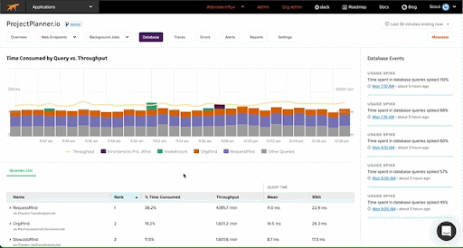
Apart from capturing the metrics mentioned above, Scout also offers support for key performance indicators (KPIs) like deployment tracking, error monitoring, custom contexts, detailed tracing, and more.
Scout also provides insights about N+1 queries, memory bloat, slow database queries, and integrates with Github (for code-level visibility), Slack (for real-time alerts), and several other platforms.
As far as PHP frameworks are concerned, Scout seamlessly integrates with Laravel and Symfony, and provides auto-instrumentation for popular libraries like Lumen, Predis, and more. You can learn more about monitoring PHP applications with Scout here.

Xdebug
URL: https://xdebug.org/
Price: Free (GPL)
Features:
XDebug is an extremely popular free, open-source PHP extension that offers a suite of tools for developers — for debugging, error reporting, tracing, profiling, and code coverage analysis. XDebug’s in-built profiler effectively identifies function calls that slow your application down and their memory consumption.
The profiler outputs the analysis to a Cachegrind compatible file format, which can be parsed and visualized using tools such as KCacheGrind and Webgrind.
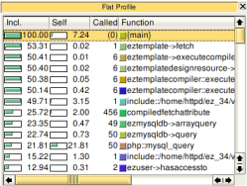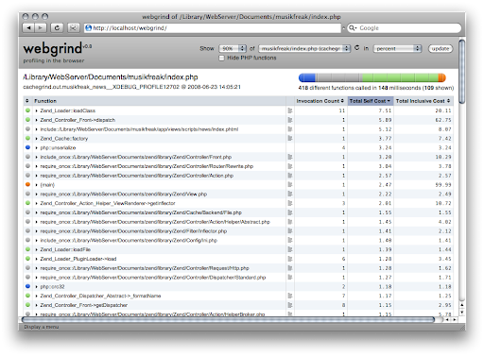
Source: XDebug and Webgrind
XDebug has primarily been known for its step debugger. The debugger allows you to interactively step through PHP code lines, visualize control flow, debug issues, and smoothly becomes a part of your development workflow by easily integrating with popular IDEs (like Visual Studio Code).
Additionally, XDebug’s tracing support for identifying stack traces in code also proves to be very handy for developers when debugging errors. You can learn more about XDebug’s debugger, profiler, setup instructions, features, and more here.

Loggly
URL: https://www.loggly.com/
Price: Free trial https://www.loggly.com/plans-and-pricing/
Features:
Loggly is a log management and monitoring platform for PHP applications by SolarWinds.
It aggregates logs across all your deployed servers and nodes in one place, a task otherwise very cumbersome to synchronize for distributed applications. Once collated, Loggly analyses and monitors these logs for insights and trends in application performance.
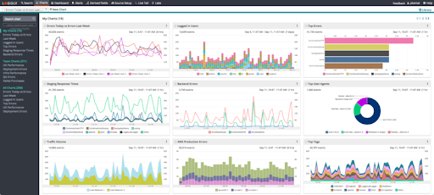
Source
You can imagine how sifting through these unnecessarily lengthy log files and locating abnormal behavior can be a real pain. Loggly makes perusing these extensive logs effortless with an interactive search interface and a quick summary of events to highlight outliers. The sample dashboard image above also shows how neat and effective their log-analysis visualizations can gather actionable insights about application performance.
Logging and monitoring go hand in hand.

AppOptics
URL: https://www.appoptics.com/application-performance-monitoring
Price: From $9.99 monthly
Features:
AppOptics is another popular APM tool that offers infrastructure health monitoring services. Like most APM tools, AppOptics offers accurately summarised metrics about your application’s performance like those we previously looked at in this post (response time, error rate, CPU usage, etc.).
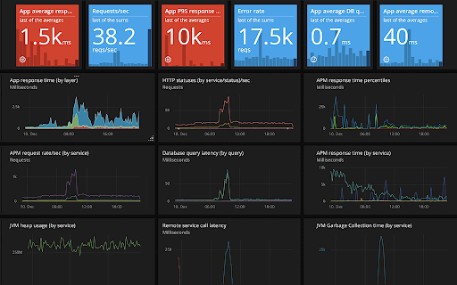
Source
On top of traditional APM features, AppOptics offers performance monitoring capabilities in pre-production settings, distributed transaction tracing, exception tracking, live code profiling, and integration with log management systems like Loggly. AppOptics also boasts a simplistic platform for their users to quickly diagnose root causes that are limiting performance, including slow database queries, high latency service calls, time-taking user-defined methods, and whatnot.
Learn more about AppOptics and their suite of monitoring services here.

New Relic One
URL: https://docs.newrelic.com/docs/apm/agents/php-agent/getting-started/introduction-new-relic-php/
Price: starts from $0 https://newrelic.com/pricing
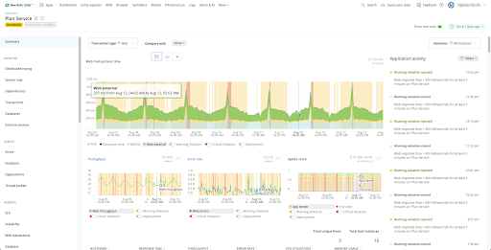
Source
NewRelic One is an industry leader in APM platforms, recognized by Gartner for nine consecutive years. It provides a comprehensive APM platform with full-stack observability into your entire software stack in one place. Apart from offering traditional APM features, NewRelic also provides AIOps capabilities to analyze events, identify data trends, reduce alert noise, and uncover insights to boost application performance. Moreover, it also includes a free subscription plan with limited features for users who want to get a flavor of what the platform offers.
Below listed are a few of their exciting features:
- High-level application summary page
- Visualize service (architectural) maps of your application
- Key transaction tracking with contextual logs
- Custom application records querying using NRQL (New Relic Query Language)
- Custom metrics with customizable interactive dashboards for visualization
NewRelic is trusted by popular organizations such as Github, Atlassian, Epic Games, Cloudfare, and more.

Dynatrace

URL: https://www.dynatrace.com/technologies/php-monitoring/
Price: FullStack monitoring starts from $74 per month for 8Gb per Host https://www.dynatrace.com/pricing/#full-stack-monitoring

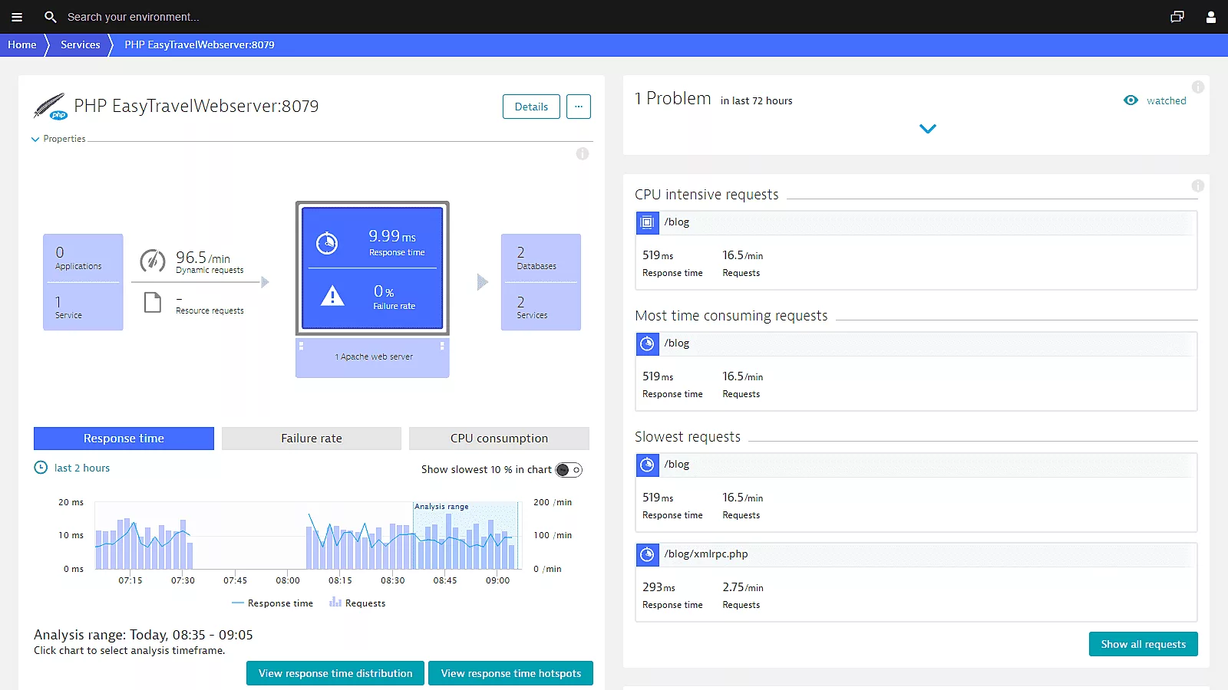

Features
- Dynatrace captures every transaction, across every tier, without gaps or blind spots.
- Pre-configured dashboards provide all relevant metrics down to SQL statement and code level.
- In under five minutes our OneAgent automatically discovers your entire PHP application stack.

Performace Details
- Worker processes
- Compilation time
- Execution time
- All database statements
- All requests, all dependencies
- Response time
- Failure rate
- Throughput
- Request and response sizes
- Restarts, crashes, deployment changes
- Apdex score
- CPU and memory usage
- Garbage collection suspension time
- Network traffic
- TCP requests and retransmission

ManageEngine PHP Performance Monitoring

URL: https://www.manageengine.com/products/applications_manager/php-performance-monitoring.html

Price:
30 days trial (Professional or Enterpricse edition). After your 30-day free trial ends, your installation will automatically convert to the free edition unless you apply for a commercial license.
Ful pricing: https://store.manageengine.com/applications_manager/perpetual.html

Features:

Application Performance Monitoring
Monitor and troubleshoot application performance issues in Dev, QA, and production environments with:
- Code-level insights
- Distributed transaction tracing
- Application service maps, and more.
Supports Java, .NET, .NET core, Node.js, PHP and Ruby applications.

Synthetic transaction monitoring
Create better customer experiences by testing the performance of critical user paths on your website 24x7.
- Selenium based scripting of tests.
- Checks from real browsers (Chrome/Firefox).
- Test from multiple locations - enterprise branch offices or actual customer locations.
- Take screenshots if there are errors.

Real User Monitoring
Monitor front-end performance based on actual traffic.
- Detailed info on network, front-end and back-end response times.
- Performance by geographies, browsers, device types, and ISPs.
- Insights into web transactions, user sessions, AJAX calls, Javascript errors, etc.
- Response times based on first-party, third-party and CDN networks.

Multi-cloud monitoring
Gain visibility into your private, public and hybrid cloud resources. Monitor workloads and troubleshoot application performance on cloud and virtualization platforms like AWS, Azure, GCP, Oracle Cloud and OpenStack. Detect service outages, application lags, server downtime, and other bottlenecks inside and outside your cloud environment.

Server Monitoring
Monitor and troubleshoot issues with server health and performance — on physical, virtual as well as cloud environments. Prevent server downtime, make sure server has enough resources, and plan capacity effectively.

Database monitoring
Easily identify and solve database issues that impact application performance. Agentless monitoring for a wide variety of databases - including RDBMS (eg:Oracle, SQL server), NoSQL (MongoDB), in-memory (memcached) and big data stores (Hadoop). Drill down to SQL statements, identify and monitor slow database calls.

Container monitoring
Stay on top of outages and pinpoint server issues with root cause analysis capabilities. Resolve issues and ensure that the resources are not overloaded to help applications run better. Proactively monitor and optimize the performance of Docker, Kubernetes and Red Hat OpenShift containers and applications.

ERP monitoring
Improve the overall performance and availability of popular ERP solutions like SAP, Oracle EBS, Microsoft Dynamics CRM & AX, and Siebel CRM. Identify, understand, and predict performance issues and bottlenecks up front with ease.

Website monitoring
Monitor the performance of your website as well as internet services like HTTPS, DNS server, FTP server, SSL/TLS certificate, SMTP server, POP server, URLs, REST APIs, SOAP web service, and more.

Automated discovery & dependency mapping
Auto-discover applications and services and map data into a real-time dependency map which shows the relationships and dependencies for all entities. The dependency map adapts dynamically as your environment changes. Automate remediation through integration with CMDBs.

AI assisted smart alerts
Get to the root cause of issues precisely and quickly and avoid alert storms.
- Static and dynamic thresholds.
- Proactive anomaly detection based on dynamic baselines.
- Get alerts on email, text and Slack channels.
- Track incidents on ITSM tool (ServiceNow, ServiceDesk Plus).
- Automate actions to enable self healing.

Advanced Analytics
Pull in all the relevant stats and visualize them on our application monitoring tool dashboard in a friendly way for your business.
- 500+ pre-built reports - real time and historical.
- Graphs for trend analysis, capacity planning, and forecasting (ML powered).
- No query language or coding required.
- Custom, interactive dashboards.
- Share dashboards with your stakeholders.

Site24x7
URL: https://www.site24x7.com/php-monitoring.html
Price: 30 days trial, starts from $9/mo https://www.site24x7.com/site24x7-pricing.html

Features:

Evaluate end user experience with real time performance metrics.
With the help of various performance metrics, get a detailed view on the performance of your application and identify how customer experience can be improved. Key metrics like Apdex Score, Response Time and Throughput enables you to identify bottlenecks that hinder your application performance.

Identify and eliminate slow performing database transactions.
Detect slow database calls, database usage and overall database performance with intuitive and detailed graphical representations. Pinpoint and resolve redundant database queries and optimize your application for enhanced performance.

Isolate slow invocations in your PHP code.
Using traces, identify methods with performance issues and get their execution details in a tree structure. The trace will chart the sequence of invocations of the URL. You can also identify the SQL queries executed during the transaction and thereby identify the worst performing database queries.

Integrate APM Insight with Real User Monitoring.
Obtain a 360 degree overview of your application's behavior by combining application performance monitoring and RUM. Compare and analyze web page performance for different time periods and from different geographical locations. Capture JavaScript code errors as they occur. Monitor individual web transactions and get detailed metrics on network, front-end and back-end response time.

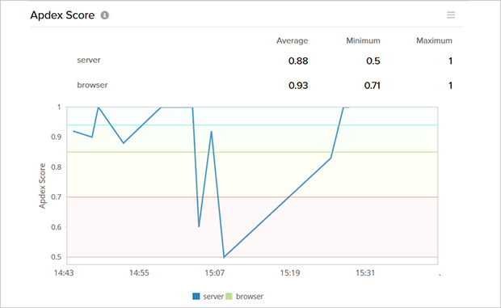
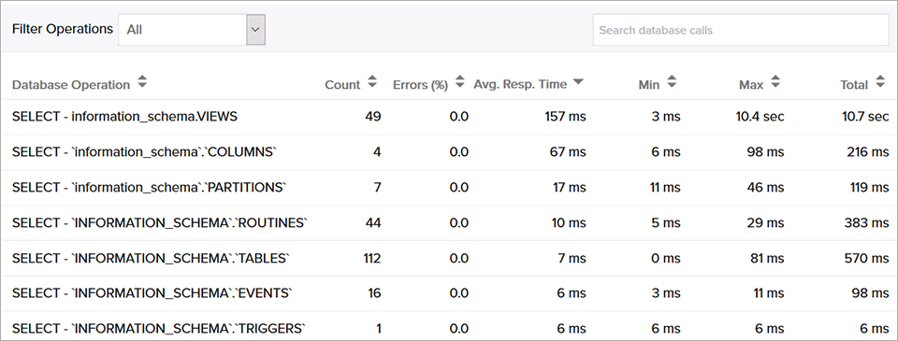

Zabbix+PHP
URL:
https://www.zabbix.com/ru/integrations/php_language
https://github.com/intellitrend/zabbixapi-php
https://github.com/ZenProjects/Zabbix-PHP-Module
Price: Free (GPL), for commercial use support subscription is recommended but not required
Features:
The variety of features provided by Zabbix itself

Sources List
1. Best PHP Monitoring Tools on the Market https://scoutapm.com/blog/php-monitoring-tool-roundup
2. Dynatrace PHP Monitoring https://www.dynatrace.com/technologies/php-monitoring/
3. ManageEngine PHP Performance Monitoring https://www.manageengine.com/products/applications_manager/php-performance-monitoring.html
4. PHP Performance Monitoring: A Developer’s Guide https://stackify.com/php-performance-monitoring-a-developers-guide/

